Drop down from Events page, Alyssa’s Ride (Banner)

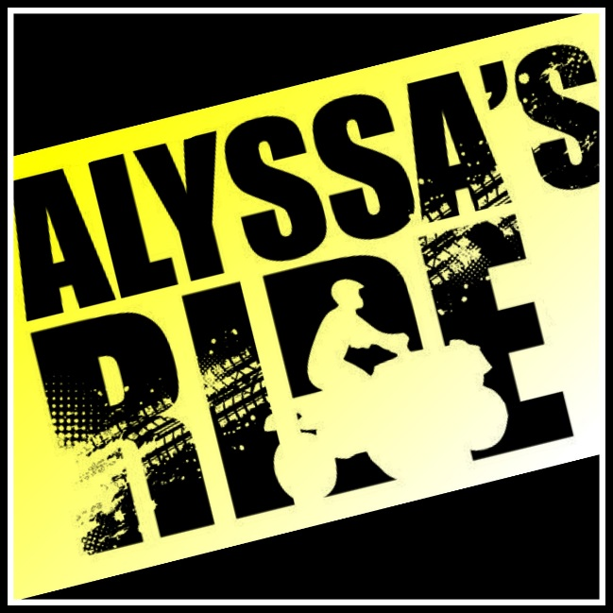E

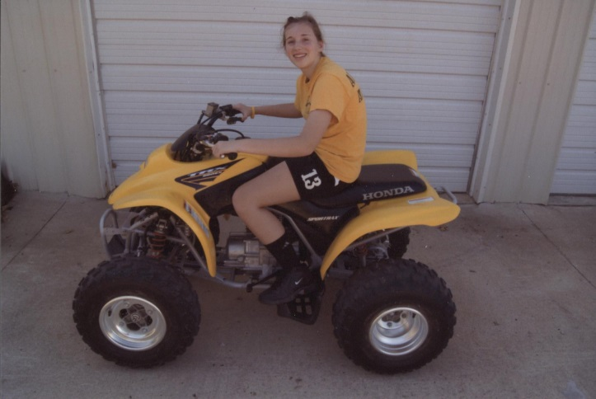After Alyssa Hutchens suffered a near death illness in February 2011, she had to basically give up her love of playing sports. She had a love for the outdoors so her parents bought her a 4-wheeler. She would spend hours riding it around the house or they would go on family rides down the country roads. Then the family learned about the McLouth, Kansas ATV Poker Run held each summer in June. Alyssa attended the first McLouth ATV Poker Run with her dad. They each rode their own ATV and Alyssa even won a raffle for a new helmet. She loved the ATV ride so much she told her mom they all had to attend the following summer. The following summer Alyssa, along with her parents, attended the Poker Run and had a blast! Then on November 10, 2014, Alyssa unexpectedly passed away. In June 2015, the McLouth ATV Poker Run was cancelled due to reasons beyond their control. In memory of Alyssa and her love of the first ever McLouth ATV Poker Run she ever attended, the First Annual Alyssa’s Ride was held on June 18, 2016.

In 2016, Remembering Alyssa, Inc., a non-profit organization was formed in memory of Alyssa. Alyssa’s Ride is an ATV/UTV Poker Run that takes place annually on the third Saturday in June and is open to the public. 100% of all proceeds benefit Alyssa’s favorite charities which includes Children’s Mercy, Ronald McDonald House Charities in Kansas City, A Chance to Save a Life Scholarship and Alyssa Lane Hutchens Family Memorial Scholarship at Pleasant Ridge High School, Alyssa Lane Hutchens Critical Care Transport Scholarship at Children’s Mercy, and building a new water well in Uganda, Africa.

The ride is an opportunity for people to come together for a day of fun and fond memories of Alyssa. The organization greatly appreciates your involvement and participation to help make this charity ride a successful event.

Click here to pre-register on-line

If you have already registered on-line and still need to pay, Click here

Or you can register to ride with us by downloading this form:

Registration Mail-In Form

Complete and mail along with your check to:

Remembering Alyssa, Inc. P.O. Box 4 Easton, KS 66020